1. Create a Registration Form using HTML 5 and CSS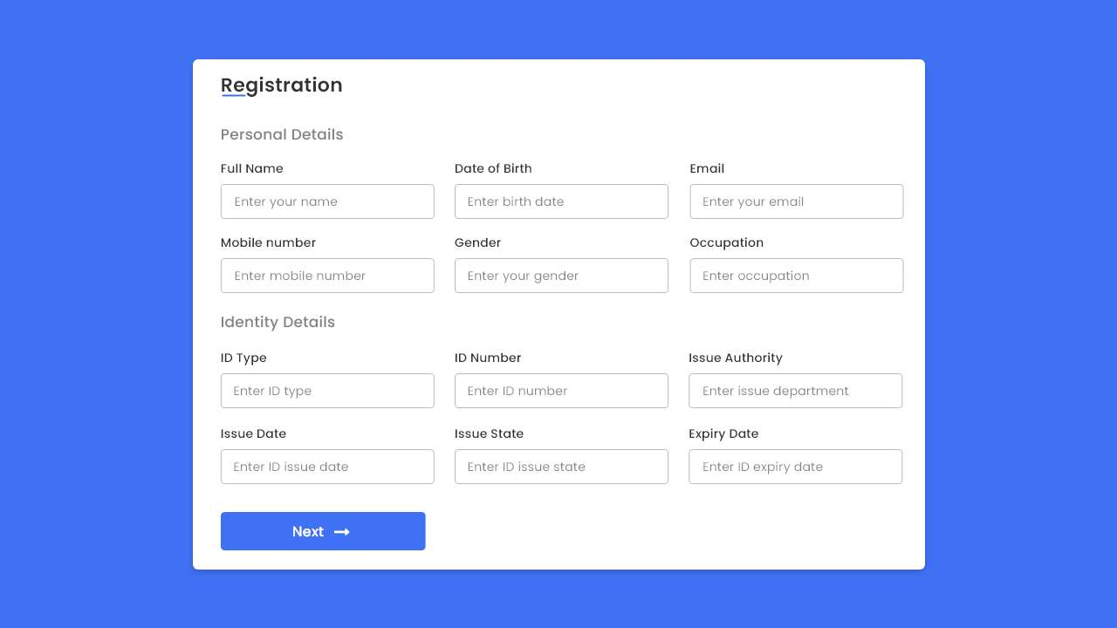

Add validations, use event handlers like onHover, onClick

When you submit the form and click on the next button it should display the data in the console and next page

1. Write an Array list of Competitive exam courses like JEE, CAT, NEET and this Array list will have properties

course_id

course_name

course_teacher

course_duration

total_fees.

Add 15 elements to the list and write Lambda expression to sort this list based

* on price in descending order and

* if price is same, then sort on duration form shortest to longest

* and print

—-------------------------------------------------------------------------------